NATIONAL LEPROSY & TB CONTROL PROGRAM-NLTCP

MINISTRY OF HEALTH

**P. O. BOX 10-1240**

**1000 MONROVIA 10, LIBERIA**

**Quarterly Supervision and mentorship report (TB REACH Project), March. 10, 2024**

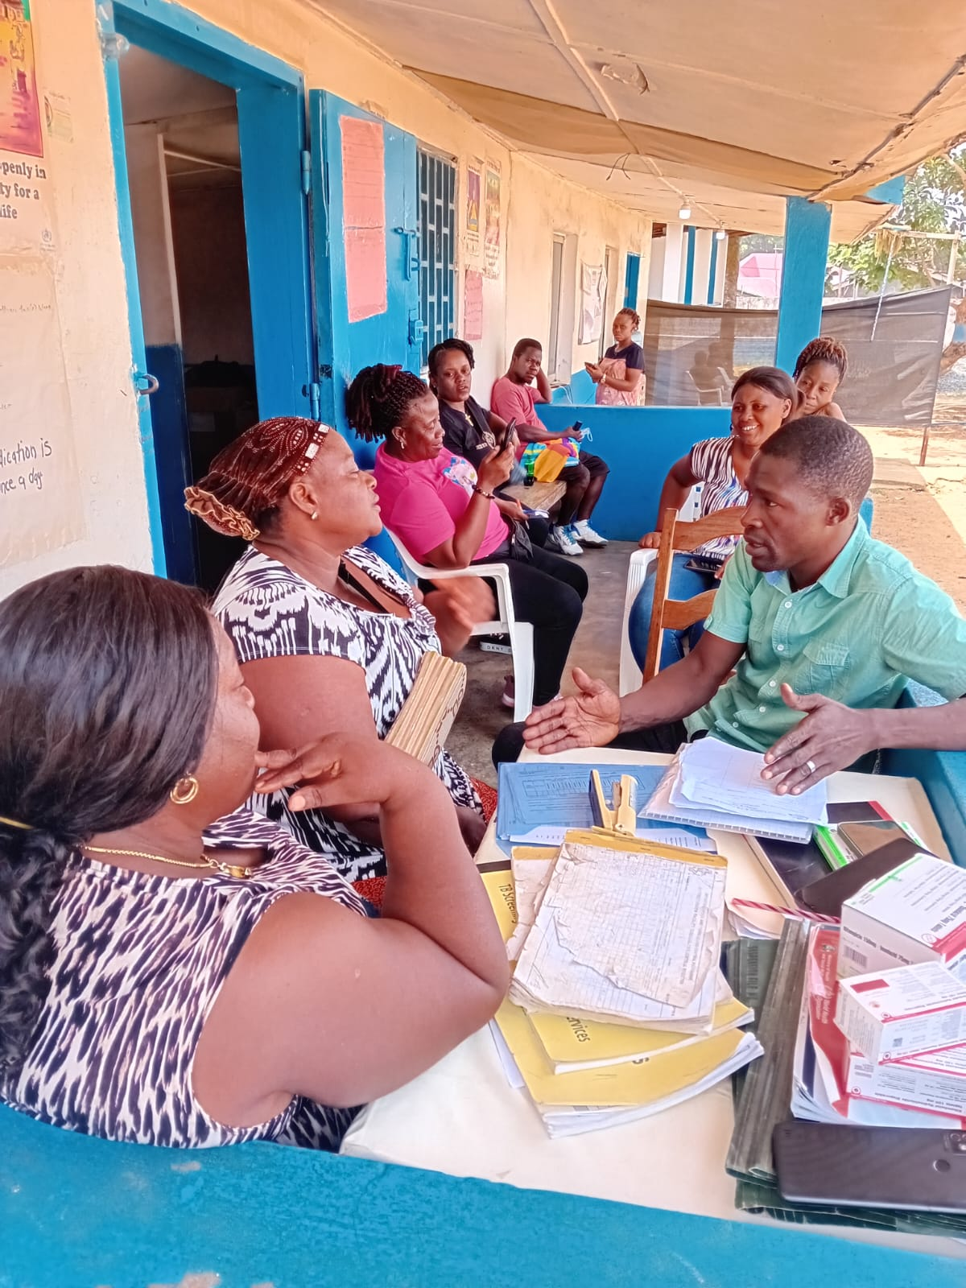

**Barnesville Health Supervision photo with the Clinicians**

**SUBMITTED To:**

**Dr. Amelia T. Weah-Liberty**

**Deputy Program Manager for Programs**

**National Leprosy & TB Control Program**

**SUBMITTED By:**

**Joe B. Beangar on behalf of the teams**

**Notional Leprosy &TB Control Program**

**Outline**

Cover Page……………………………………………………………………………………..1

Introduction/Background---------------------------------------------------------3

Expected Outcome…………………………………………………...4

Team one update…………………………… ……………………………………….4 to 5

Team two update……………………………………………………………….…...6 to 8

Team Three update----------------------------------------------------------9 to 21

Team Four update…………………………………………………………………..21 to 24

**Background**

TB Control Program received funding from the Carter Center (TCC), an international non-governmental organization to implement the TB REACH project in Montserrado County.

The funding make NLTCP responsible for implementation of monitoring and supervisory oversight of all forty-six (46) project facilities to ensure effective TB & MH service delivery by trained service providers. Also, the supervision strengthened collaboration between TB program and the MH unit/Clinicians, documented implementation experience.

**Supervision Objective**

The main objective of the of this Supervision was to conduct mentorship for TB/MH service providers on TB Screening, Case Management, Diagnosis, treatment, to improves case detection, increase case notification and reduce unfavorable treatment outcome in 46 TB Facilities in Montserrado County.

On March 1 to 8, 2024 the teams begin her supervision which was able to covered 46 health facilities as planned.

Supervision Specific Objectives:

* Independently, the facility staff to conduct TB systematic screening
* Document all TB presumptive patients in the facility TB presumptive ledgers’
* Timely Initiate all TB patients on treatment
* Record and report all TB registered patients on a monthly and quarterly basis

Supervision **Methodology**

There was formation of four teams, and each team was comprised of 1 case Manager, 1 laboratory personnel, 1 M&E personnel, one person from the Montserrado County health, and a driver, making the total of 5 persons.

The team used to move in the facility early in the morning to enable us to form part of the screening/triage process, thereby straightening the screening and onward identifying the TB presumptive patient in the facilities. Some facility was doing well, and the team asked them to keep up the good work.

**Expected Outcome**

The NLTCP expects the following outcome from the quarterly Supervision, feedback dissemination, and mentorship.

* Full screening of all patients that enter the facilities for TB.
* Recording and reporting of all TB presumptive patients
* Increase in case notification by identifying missing cases
* Strengthened collaboration and integration of TB/MH services at the targeted health facilities
* Improvement in treatment success rate
* Reduction in loss to follow
* Competence /Increase in the number of health facilities offering integrated TB/MH services

Update from each facility

|  |  |  |  |
| --- | --- | --- | --- |
| **No.** | **Activities** | **Observation** | **Action** |
| 1 | **Johnsonville Clinic**: Two staff members are responsible for TB in the facility. The OIC and the TB focal person. They have a TB screening Log and are used. There were no TB presumptive ledgers during the time of our visit, which was immediately supplied and conducted coaching on the use. | Low screening seeing in the ledger with no TB case since 2021. No TB drug at the facility. No TB lab service, no sputum cups, patients sent for testing not returning with their result, etc | Supplied one TB presumptive ledger and conducted mentorships. |
| 2 | **Chocolate City Clinic**: Two staff members are responsible for TB in the facility. The one screener and the TB focal person. They have a TB screening Log and are used. There was no TB presumptive ledger during the time of our visit. TB drugs available at the facility that will still be effective for three months. Microscope is available, functional with reagents and two trained staff. | Low TB case detection. There was no TB Quarterly reporting tool. Poor recording of patient’s information. No hand gloves with a few masks. | Was immediately supplied with one Quarterly reporting tool, TB presumptive ledger, and conducted coaching on the use. |
| 3 | **R.H. Ferguson:** One mama Musah is responsible for TB activities in the facility. The OIC was added during our team visit through her willingness and conducted mentorship. They have a TB screening Log and presumptive ledger during the time of our visit. However, coaching and mentorships were done on the proper usages. | No case at the facility since the training in 2021. No TB drugs at the facility during the time of our visit. No Lab service at the facility, all patients are referred to the nearby facility for TB test. Microscope is available, but the lab staff was retired and no replacement as of now. No sputum cups at the facility. | The team conducted a mentorship, Coaching on TB and the various ledger usages. Give them communication support. |
| 4 | **Garnsvillie Clinic**: Two staff is responsible for TB in the facility. The TB focal person and the OIC. They have TB screening Log and in used. There was no TB presumptive ledger during the time of our visit. TB drugs available are at the facility, but there is no TB case. | There was no TB case during the time of our visit. No hand gloves with a few masks. No TB Lab service. Limited office space for TB screening. | Immediately supplied one TB presumptive Log. And conducted coaching on the use. Give them 15USD communication support as well. |
| 5 | **Barbra ANN Health:** Two staff members are responsible for TB in the facility. The TB focal person and an assistant. They have both the TB screening Log and the TB presumptive ledger during the time of our visit and in use. TB drugs are available that will take them up to three months. | The facility notified 82 TB patients for Oct to December 2023. Facility report copy was seen during our visit. The facility has one Genexpert machine with one module non-functional. No box files for TB treatment cards. | The team conducted coaching and mentorship on proper recording on the date sample collected, the results, the HIV test from the TB card to the ledger, etc. |
| 6 | Barnesville H.C: Two staff is responsible for TB in the facility. The TB focal person and a assistant. They have both TB screening Log and TB presumptive ledger during the time of our visit and in use. TB drugs is available that will take them up to three months. The facility notified 109 TB patients for Oct to December 2023. | Facility report copy was seen during our visit. The. No box files for TB treatment cards. No masks and glove at the facility. Carbofusion expired, no pencil for lab use. | The team supplied 1 pair of gloves to the lab, Carbofusion, pencil, marker, lens tissues, lab register, for lab use. |
| 7 | **Pipeline Health center:** Two staff members are responsible for TB in the facility. The TB focal person and an assistant. They have both the TB screening Log and the TB presumptive ledger during the time of our visit and in use. TB drugs are available that will take them up to three months. The facility notified 31 TB patients for Oct to December 2023 | Patients sent by clinicians transported by rider have no feedback on the result.  Facility has a microscope, but does TB diagnosis test at another facility | Give them 15USD communication support. Did mentorships and coaching TB screening and Presumptive log. |
| 8 | **St-Benedict Mini Clinic:** Two staff members are responsible for TB in the facility. The TB focal person and an assistant. They have both the TB screening Log and the TB presumptive ledger during the time of our visit and in use. TB drugs are available that will take them up to three months. The facility notified 26 TB patients for Oct to December 2023 | Facility have microscope but do TB diagnosis test at other facility. No hand glove, face Masks, hand washing bucket, No Patient ID Card. No bio-safety carbonate to prepare smear in the Lab. | Give them 15USD communication support. Did mentorships and coaching on TB screening and Presumptive log use. |
| 9. | **Lofa Medic Clinic:** One staff responsible for TB activities in the facility. They have both the TB screening Log and the TB presumptive ledger during the time of our visit. Screening log was partially in use while the presumptive register was not in use at all. TB drugs were available. The facility notified 10 TB patients for Oct to December 2023 | No Lab service at the facility. TB patient not screened for MH. No Masks, hand gloves, not enough space in the screening room for proper distance b/w pt and the screener. Pt registration fees (250LD) make it difficult for patients to continue treatment at the facility. | Onsite Mentoring and coaching conducted. |
| 10 | **New Georgia Health Center:** One staff member responsible for TB activities in the facility. They have both the TB screening Log and the TB presumptive ledger available during the time of our visit and in use. TB drugs were available. The facility notified 56 TB patients for October to December 2023. | No lab service, all diagnosis is done at the nearby facility. Some manner errors observed in the ledgers. | Onsite Mentoring and coaching conducted. |
| 11 | **Blamacee Clinic:** Two persons were identified to implement TB activities in the facility**, (Janet Tiah and the OIC)** | No lab service. No TB case at facility | Onsite Mentoring and coaching conducted |

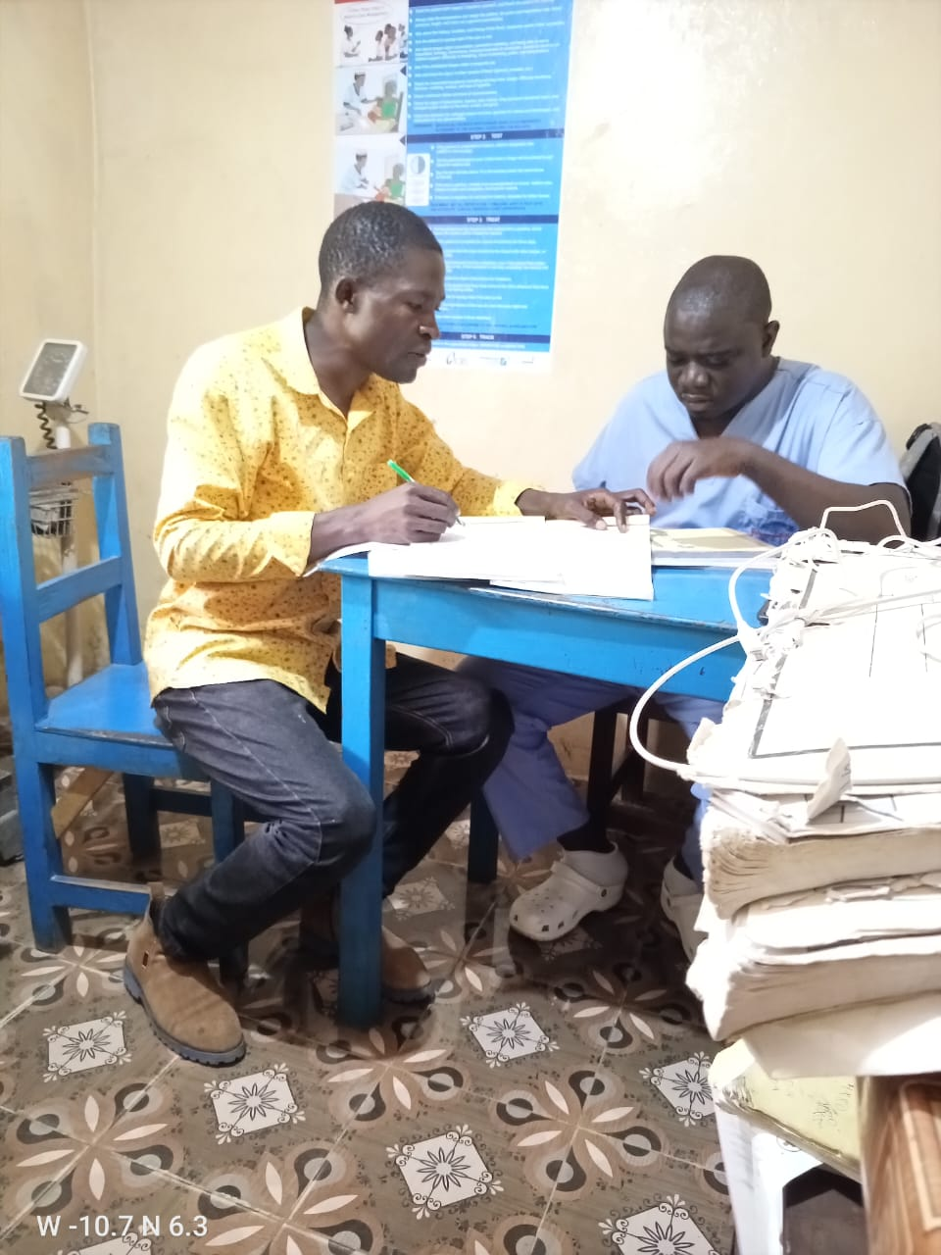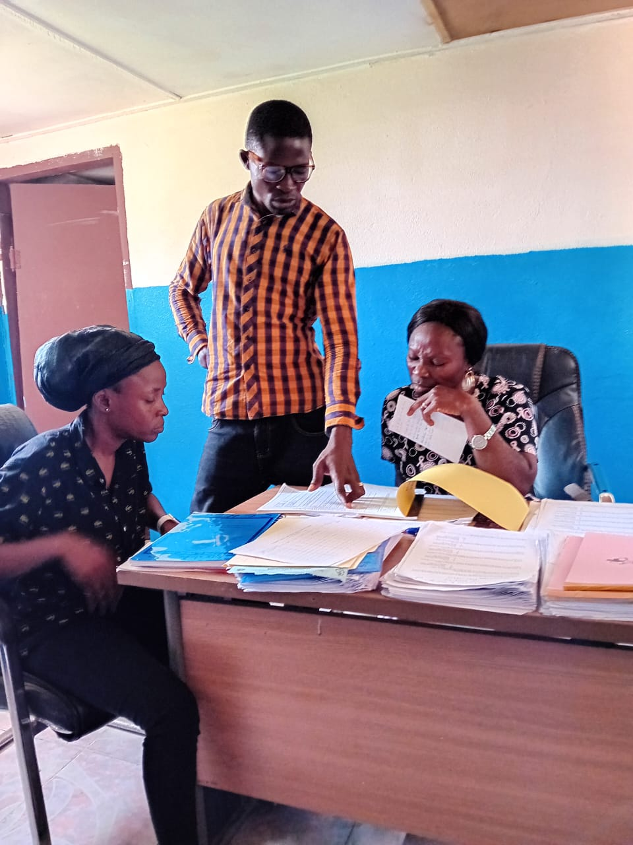

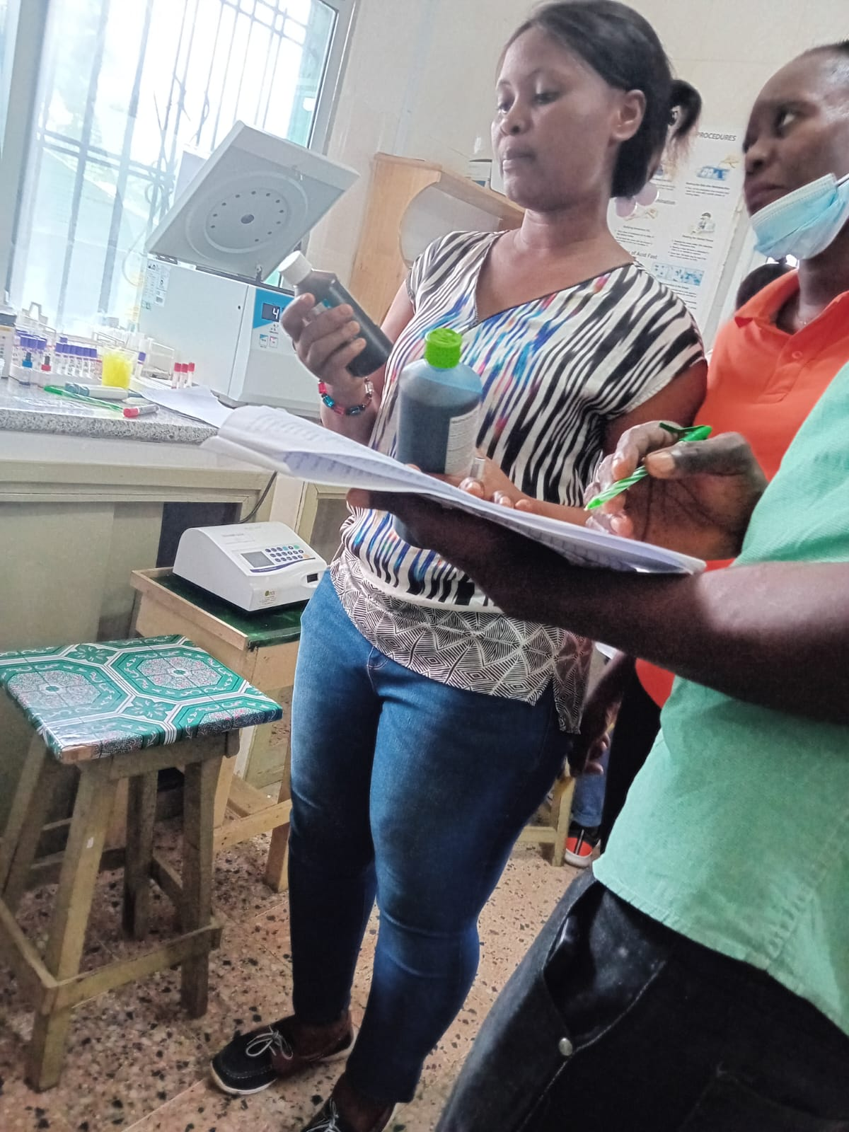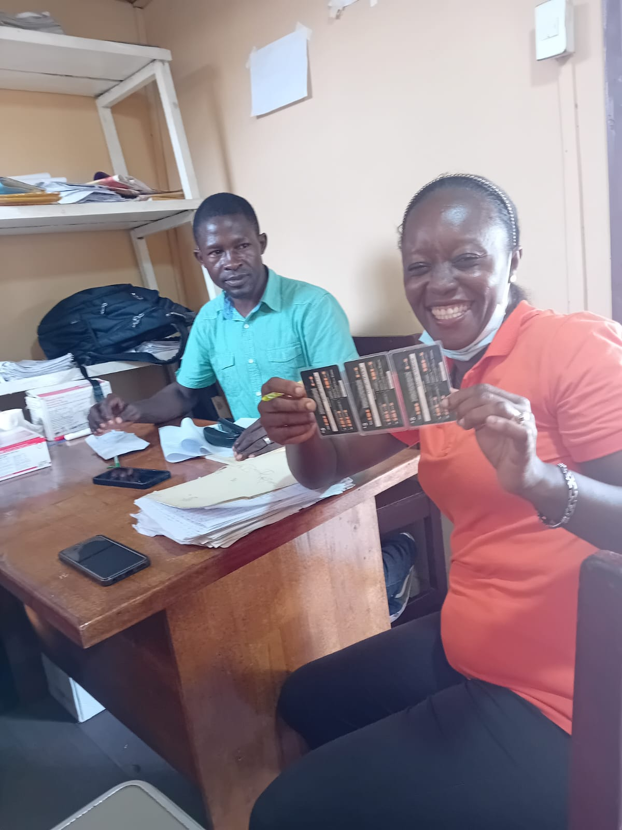**Checking reagent expiration date**

**Barbra Ann Clinician happily receiving her**

**Communication supports from the team**

**Team two reports**

**Strengths:**

* A dedicated and trained TB clinician/ Focal Person at all facilities visited
* Facilities staff were receptive and willing to learn/Listing
* 100% of facilities visited have anti-TB Drugs available that can go for 3-4 months
* 85% of notified TB cases tested for HIV and placed on ART
* All missing TB RR Tools were supplied

**Opportunities:**

* AFB / ZN Reagents, available
* HIV Test kits are available
* 50% Facilities have microscopes
* 100% of facilities visited have Anti-TB Drugs available
* 85% of facilities visited have TB reporting and Recording Tools, except the screening Log book

**Weaknesses:**

* Lack of county-level supervision by the TB/HIV focal person
* Limited TB screening done at all facilities visited
* No mentorship by CHT
* Some facilities did not have a screening log during the visit

**Threats**

* Bishop John Collins, Acid Alcohol and Carbolfuchsin all expired during the time of visit
* Staff Attrition
* Diagnostic services are not available at the following facilities: RCD Marshall, AF Russell, Kpala Clinic, Banjor Clinic, Slip Way Clinic, and Liberia Albino Society clinic
* No Trained staff in IPT activities
* The Redemption Hospital air conditioning line was stolen, so there was no Diagnostic activity at the facility during the time of visit
* Limited IPC supply at all facilities visited
* Standard TB (IPC) is not being practiced in all facilities visited

**Key findings**

* All notified TB cases are tested for HIV and documented, while all TB cases are also screened for mental health with forms attached to patients' chats
* No active TB screening going on at all facilities visited
* Staff did not understand the screening process
* TB reporting and recording tools not properly updated with all necessary information
* Anti TB Drugs available at all facilities visited with expiration date: November 2025 and December 2026.
* Staff at RCD Marshall and Kpalla were well coordinated and willing to learn
* 80-90% of facilities visited have TB reporting and recording tools, with mental health screening tools
* TPT services, Limited at all facilities visited
* TB ICC & BCC materials were available at all facilities visited

**Challenges**

* Facility staff informed the team that the screening is an extra work, especially for bigger facilities like Redemption, among others
* Lack of regular mentorship and supervision
* All follow-up laboratory testing not done at Star of the Sea
* The redemption air conditional line was stolen, so no laboratory activities were going on at the facility during the team visit

**Recommendations:**

That the CHT / Bio-medical Tech connects the solar panel cable/extension to the Lab for the flow of electricity

* That the TB/HIV focal person conduct mentoring during their monthly supervision
* That staff in the facility be trained in TB case management and TB AFB microscopy by CHT/NLTCP
* That there should be a proper inventory of drugs done, and timely unforeseen stock out be reported to the National Program

**Nyehn Health Center**

**Observation/Finding**

Nyehn Health Center has two TB clinicians who have been trained on the TB/MH integrated Project. However, only one was present during the visit. The facility is a public facility that provides both TB Diagnostic and treatment services.

**TB Screening**

TB Screening log was available, it was supplied to the facility since November 2023 but the screening log book not been use for screening patients.

**Other TB Recording and Reporting**

Presumptive register was available but not in use, TB treatment cards, sputum requisition form, Referral/Transfer booklet, TB Treatment register, and the Guideline were also available

**TB case notification and documentation**

The facility notified 21 TB cases for quarter 4, October to December 2023, and almost all TB patients were screened for mental health conditions. All patients with a mental condition were also screened for TB. All TB patients were also tested for HIV. The documentation process was correctly done in the Treatment cards and the Treatment Register.

**TB Drugs**

TB drugs were available at the facility (RHZE 48 blisters, RH 240 blisters, RHZ 72 blisters, and RH peds 96 blisters, expiration date June 2025)

**TB IPC**

Face surgical masks were available, but no examination gloves in the screening rooms except for the OB ward and the laboratory. Hand washing bucket available

**Challenges**

No designated staff to Triage patients using the TB screening log booklet

**Action Taken**

The TB clinician and other staff were mentored on the use of the screening log booklet and presumptive register. The mentoring process included demonstration and return demonstration on the screening of patients with proper recording. The clinicians were appreciated for good recording keeping and encouraged to continue the excellent record keeping. The TB Clinician also received 15 dollars in orange scratch cards for the patient’s follow-up.

**Laboratory**

* The lab has a functional microscope and testing for TB
* The lab has two laboratory assistants, but one was available during the supervision visit
* The lab is spacious and ventilated with a sink to stain TB slides
* Sputum boxes are available to store patients' slides and quality control (QC) slides
* There is no running water, but there is water in a bucket to carry on the staining process
* TB reagents and consumables are available and expiration dates follow: Carbon fusion Nov. 2024, Acid Alcohol Nov. 2024, and Methylene blue Nov. 2024
* Laboratory results are written correctly in the register according to TB protocol
* SOPs for sputum processing are available but not placed on the wall in the lab
* Blinded rechecking EQA code is not known by lab staff and was provided immediately during supervision
* Quality control is not done, but the team mentored lab staff on the QC process and storage

**Recommendation**

Continue supervision and mentoring to build the capacity of other facility staff that are trained but providing services.

NLTCP/TCC/ MCHT to provide a motivation incentive for a designated staff to triage all patients for TB.

**Bensonville Hospital**

**Observation/Finding**

Bensonville Hospital has two trained TB clinicians and two Mental Health clinicians; however, the facility TB focal person was absent on the day of supervision. Other screeners and one mental health clinician were present during the supervision visit. The facility is a public Hospital that provides both TB Diagnostic and Treatment services

**Screening for TB & Mental health conditions**

The TB Screening log was available, it was supplied to the facility since November 2023, but the screening log book was not in use for the screening of patients. Also, mental health patients in care are not screened for TB

**Other TB Recording and Reporting**

Presumptive register was available but not in use, TB treatment cards, sputum requisition form, Referral/Transfer booklet, TB Treatment register, Contact tracing register, and Guideline were also available

**TB case notification and documentation**

The facility notified 7 TB cases for quarter 4, October to December 2023, and all TB patients were screened for mental health conditions. All patients with mental conditions were not screened for TB. All TB patients were tested for HIV. Recording in the treatment cards and register was good, some minor errors identified were corrected

**TB Drugs**

TB drugs were available at the facility (RHZE 504 blister, RH 1008 blister, RHZ 60 blisters, and RH peds 108 blister expiration date June 2025)

**TB IPC**

Face surgical mask were available but no examination glove in the screening rooms except for the OB word and laboratory. Hand washing bucket available. Screening room had good ventilation.

**Challenges**

TB Clinicians are on rotated schedule with other screeners who are not trained

**Action Taken/Mentorship**

The Mental Health Clinician and other staff were mentored on the use of the screening log booklet and presumptive register. The mentoring process included demonstration and return demonstration on the screening of patients with proper recording. The facilities triage nurse was part of the mentoring process and took the initiative to conduct regular screening for patients entering the facility.The clinician were appreciated for good recording keeping and encourage to continue. The mental health clinician was encourage to screen all patients with conditions for TB.The Clinician received 15 dollars orange scratch cards for patient’s follow-up.

**Laboratory**

* The facility Lab has a functional microscope
* There are three lab technicians but only one was present during the visit
* Acid Alcohol and methylene blue are available in huge quantity
* Carbonfusion reagent is in huge quantity (3 cartoons) but expired August 2023
* Lab has work bench, sink, and is specious and ventilated
* No running water
* Patients names, serial # and result are written correctly in the lab register blinded rechecking EQA codes are available and used
* SOPs are not available
* Quality Control is done but in the register

**Recommendation**

Continue supervision and mentoring to building the capacity of other facility staff that are rained but providing services.

NLTCP to supply Carbonfusion and SOPs

**Careys burg Clinic**

**Observation/Finding**

**Careys burg Clinic** has a TB clinicians and mhGAP-IG trained clinician; however, the facility TB focal person is new has not been official trained for TB. Other screeners were present during the supervision visit. The facility is a public Clinic that provides both TB Diagnostic and Treatment services

**Screening for TB& Mental health conditions**

TB Screening log was available, but the screening log book was not in use for the screening of patients. We observe mental health screening record for TB in care and encourage clinician to continue.

**Other TB Recording and Reporting**

Presumptive register was available but not in use, TB treatment cards, sputum requisition form, Referral/Transfer booklet, TB Treatment register, contact tracing register, and the Guideline were also available

**TB case notification and documentation**

The facility notified 5 TB cases for quarter 4, October to December 2023, and all TB patients were screened for mental health conditions. All patients with a mental condition were also screened for TB. All TB patients were tested for HIV. Recording in the treatment cards and register was good, some minor errors identified were corrected

**TB Drugs**

TB drugs were available at the facility. The OIC was not present the check the quantity of TB Drugs available at the facility. According to the TB clinician the drugs is enough for three months and expiration date is Nov. 2025.

**TB IPC**

Face surgical mask were available but no examination glove in the screening rooms except for the OB ward and laboratory. Hand washing bucket available. Screening room ventilation not too good.

**Challenges**

No Designated staff to Triage patients using the TB screening log book

**Action Taken/Mentorship**

The TB Clinician and other staff were mentored on the use of the screening log booklet and presumptive register. The mentoring process included demonstration and return demonstration on the screening of patients with proper recording. The clinicians were appreciated for good recording keeping and encourage to continue. The TB Clinician also received 15 dollars orange scratch cards for patient’s follow-up.

**Laboratory**

* The facility has a functional microscope and two lab staff, an assistant and an aide, only the lab aide was present during the visit
* Reagents and consumables are available with these expiration dates acid alcohol Nov. 2024, Methylene blue Nov. 2024 and Carbonfusion August 2023.
* Correction was made by the team on test results, some positive results were written in blue while a 3+ positive result was written as positive
* Patient names and serial # were correctly written
* Blinded rechecking EQA code is not used
* NO QC done, mentored staff on QC processing and storing
* Has one slide box

**Recommendation**

Continue supervision and mentoring to build the capacity of other facility staff that are trained but providing services.

NLTCP to supply Carbonfusion, slides, and Lab register

**Mount Barclay Clinic**

**Observation/Finding**

Mount Barclay Clinic has TB clinicians who have been trained on the TB/MH integrated Project. However, the TB Clinician was not present during the supervision visit. The OIC and other screeners were present. The facility is a public facility that provides TB treatment services.

**Screening for TB& MH Conditions**

TB Screening log was available and is in use but only few patients were screened. Also all TB patients were screened for mental health conditions.

**Other TB Recording and Reporting**

Presumptive register was available and in use, TB treatment cards, sputum requisition form, Referral/Transfer booklet, TB Treatment register, and the Guideline were also available

**TB Case notification and documentation**

The facility notified 3 TB cases for quarter 4, October to December 2023 and almost all TB patients were screened for mental health conditions. All patients with mental condition were also screened for TB. All TB patients were also tested for HIV. The documentation process was correctly done in Treatment cards and Treatment Register.

**TB Drugs**

TB drugs were available at the facility (RHZE 552 blisters expiration Nov. 2025, RH 960 blisters expiration May 2026, RHZ 60 blisters expiration Dec. 2024, RH peds 120 blisters expiration date June 2025, and Ethambutol)

**TB IPC**

Face surgical masks and examination gloves were not available except for the OB ward and laboratory. Hand washing bucket available in the screening room. Poor ventilation was observe in the screening rooms.

**Challenges**

Incentive for designated staff to Triage patients using the TB screening log book

**Action Taken**

The OIC and other staff were mentored on the use of the screening log book and presumptive register. The mentoring process included demonstration and return demonstration on the screening of patients with proper recording. The clinicians were appreciated for good recording keeping and encouraged to continue the excellent record keeping. They were also encouraging to continue and improve on the screening process for both TB& MH conditions. OIC also received 15 dollars in orange scratch cards for patients’ follow-up at the end of the mentoring process.

**Laboratory**

* The facility has a functional lab with two laboratory assistants who are volunteers, but not testing for TB
* Has three lab assistants, only one person trained in the TB diagnosis technique
* An extension is built outside of the lab for sputum processing and staining
* No lab work bench and sink in the main lab, only one big table
* Lab is spacious and ventilated
* Acid, Alcohol, and Methylene blue are available, but Carbonfusion is not supplied

**Action taken**

Requisition for one reagent was prepared and will be supplied as soon as possible

Mentoring was done on AFB smear analysis

**Koon Town Clinic, Goba Town Clinic, Yeagbah Town Clinic, Camp Sandee Ware, Crozierville Clinic, Harrisburg Clinic, White Plain Clinic and Omega Market Clinic.**

**Observation/Finding**

The above seven (8) facilities are public clinics that have TB & mhGAP-IG trained clinicians who were trained on the TB/MH integrated Project. However, all the above facilities have not reported any TB care since the scale up of these facilities as TB Treatment centers. The supervision and mentoring exercise were necessary to identify gaps and mentored clinicians on key actions to improve service delivery. The TB Clinicians in some of the following facilities, White Plain Clinic, Crozierville Yeagbah Town, were not present during the time of supervision, other clinicians present during the supervision visit were not trained, but benefited from mentorship.

**Screening for TB & MH**

All the above health facilities had TB screening log book except **Camp Sandee Ware** clinic butonly Omega market Clinic had some documented screening record for few patients in their screening log book. Screening TB patients for mental health Conditions was not observe because the facilities had no TB patient in care.TB Treatment registers and Guidelines were also available.

**Koon Town and Goba Town Clinics** had some documented screening record for mental health conditions, they were encourage to continue

**Other TB Recording and Reporting tools**

**Koon Town Clinic, Goba Town Clinic, Yeagbah Town Clinic, Camp Sandee Ware** were out ofPresumptive registers, TB treatment cards, sputum requisition form, Referral/Transfer booklet. Immediate supply was done during the supervision process.

**Crozierville Clinic, Harrisburg Clinic, and White Plain Clinic** had all of the TB recording and reporting tools available but the clinicians had limited knowledge on the use of the these tools.

**Laboratory Findings**

**Goba Town Clinic**

* Lab established in 2018, and not testing for TB, and has one Lab Assistant, trained in 2020 in TB diagnosis by the Montserrado CDO
* The facility has a brand-new microscope supplied by Save the Children
* Lab space is good, has a workbench, has no sink and is not ventilated, so slide processing and staining should be done outside of the lab.
* Has a solar system but there is no current in the lab
* Recommendation: Retrain lab staff, sputum processing and staining be done outdoors

**Camp Sandee Ware Clinic**

* Has an established lab with one lab technician
* The Lab technicians were present and were trained at the TB Annex hospital lab in 2020
* The lab is not ventilated with a functional microscope
* lab is spacious, has a work bench but no sink
* No Laboratory reagents were available for TB testing

**Koon Town Clinic**

* The facility currently has no Lab, but space /room available to an established lab
* The room is spacious and well ventilated with a work bench, sink, and storage room
* Clinic has a brand-new microscope supplied by Save the Children in 2015
* The clinic has identified a lab staff member willing to work

**TB Drugs**

No TB drugs were available in all the above eight health facilities. The facilities have surgical nose masks but no examination gloves. The Triaging of coughing patients is not done in almost all the above facilities.

**Action Taken/Mentorship**

The TB clinicians and other staff at the above eight health facilities were mentored on the use of the screening log book and presumptive register. The mentoring process included demonstration and return demonstration on the screening of patients with proper recording. The staff were receptive and willing to learn. After the mentoring process, the staff promise to continue the screening daily. TB Clinicians receive the following supplies: Presumptive registers, Screening log books, TB treatment cards, sputum requisition forms, Referral/Transfer booklets, and 15 US dollars orange scratch cards per facility for patients' follow-up.

Facilities staff were encourage to screening all patients with mental health conditions for TB also screen all TB patients identify for mental health conditions. Clinician were mentored on the Triaging of coughing patients in almost all the above facilities.

**Koon Town and Goba Town Clinics** clinicians were encouraged to continue the screening of patients for mental health conditions

**Challenges**

No designated staff at the above facilities to conduct the TB screening at the triage daily. However, the TB clinicians promise to fill the gap while the program and CHT advocate to incentivize a designated staff for screening activities at the triage daily.

**Recommendation**

NLTCP to continue supervision and mentorshipto improve the capacity of clinicians and other facility staff that are not trained but are providing TB services.

NLTCP to provide refresher training for two laboratory staff at Goba Town and Camp Sandee Ware Clinics on AFB smear analysis at the TB Annex Laboratory.

NLTCP to supply Goba Town and Camp Sandee Ware clinics with laboratory reagents

MCHT to assigned Laboratory staff at Koon Town Clinic

NLTCP/Carter Center to print additional TB screening Lob book

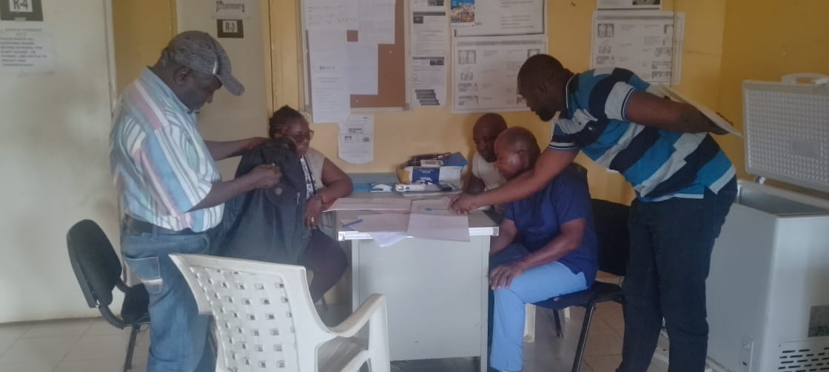Photos Gallery: Mentoring clinicians on how to screen patients for TB at Camp Sandee Ware Clinic

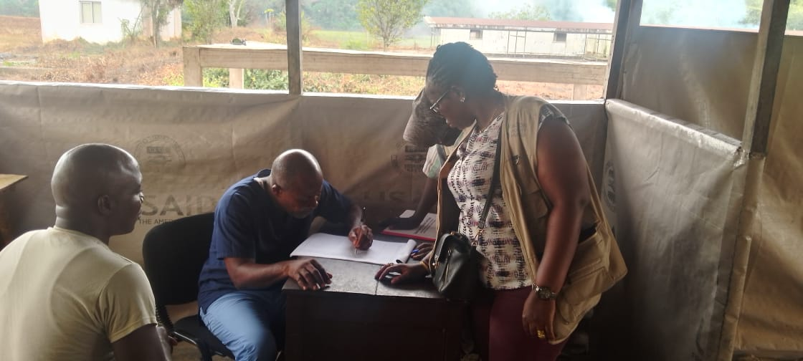Clinician demonstrating screening for TB after the mentorship at Camp Sandee Ware Clinic

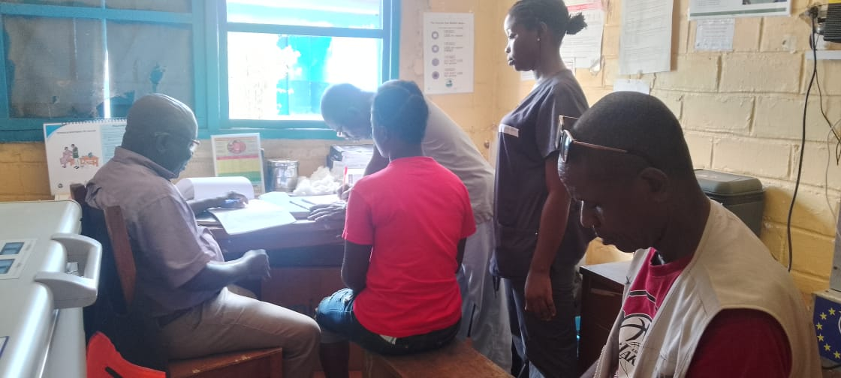Clinicians demonstrating how to screen patients for TB at Koon Town Clinic, the Todee District

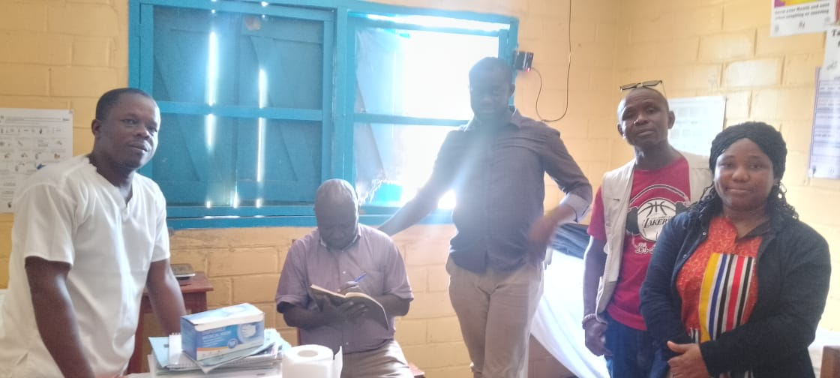Group Photo with Koon Town OIC after mentorship

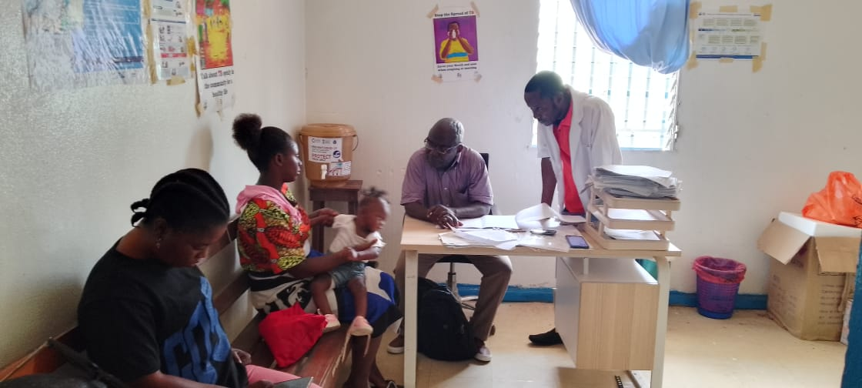Team member demonstrating how screening for TB is done at Nyehn Health Center, Todee District

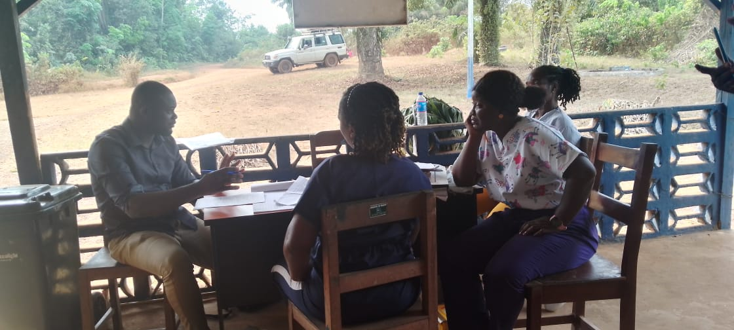Mentorship with Clinicians on Screening for TB & Mental health conditions at Goba Town Clinic, Todee District

Mentorship and demonstration on how to conduct screening for TB & Mental Health at Yeagbah Town Clinic

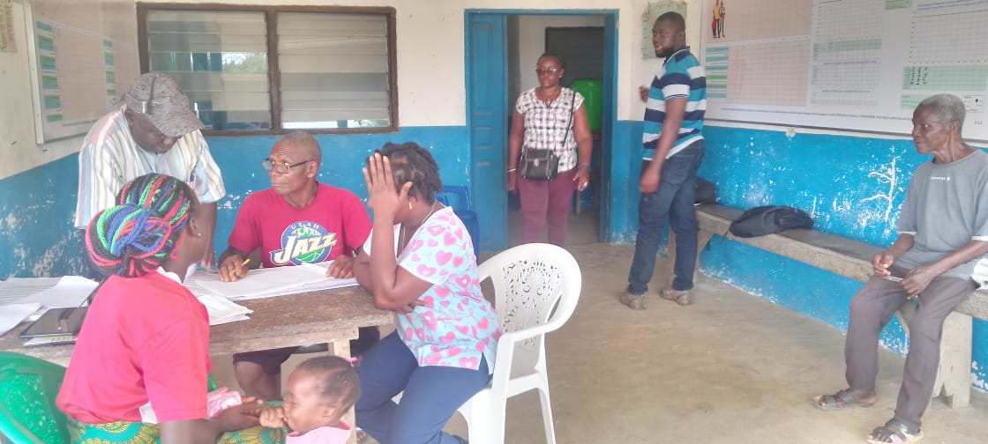

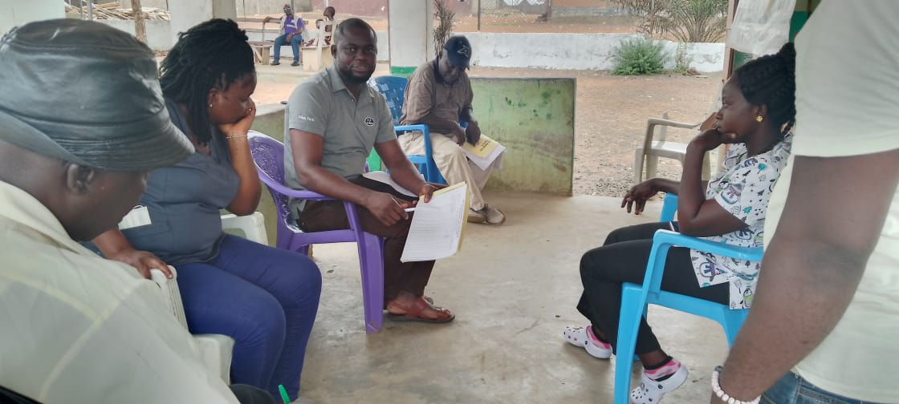Mentorship with Clinicians on Screening for TB and Mental health at Mount Barclay Clinic

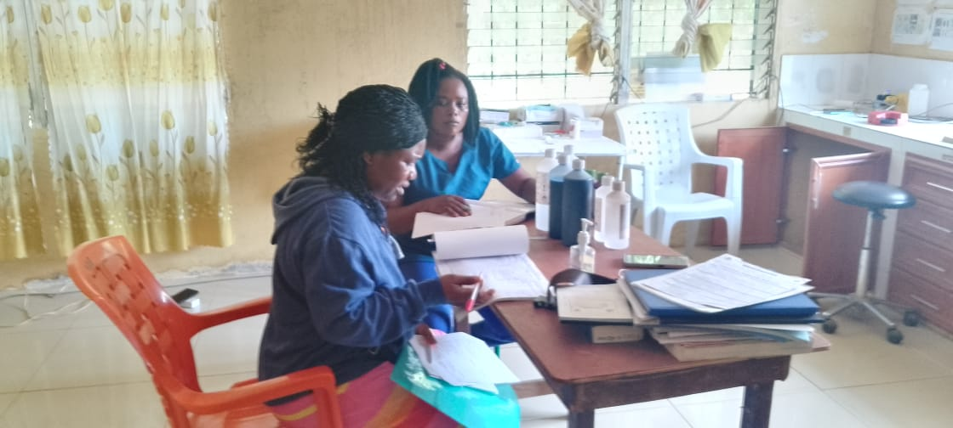Supervision and mentorship with Lab staff at Careysburg Clinic

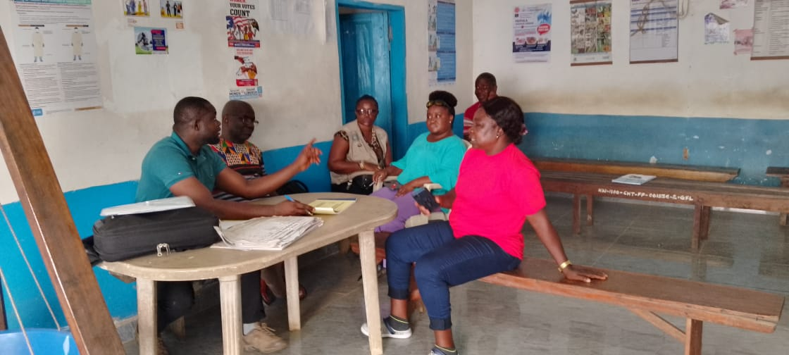Mentorship with Clinicians on Screening for TB and Mental health at Bensonville Hospital

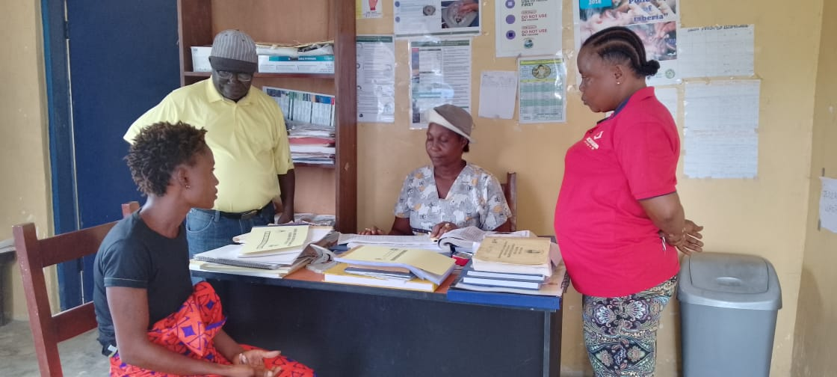Mentorship and demonstration on how the conduct screening for TB & Mental Health at White Plain Clinic

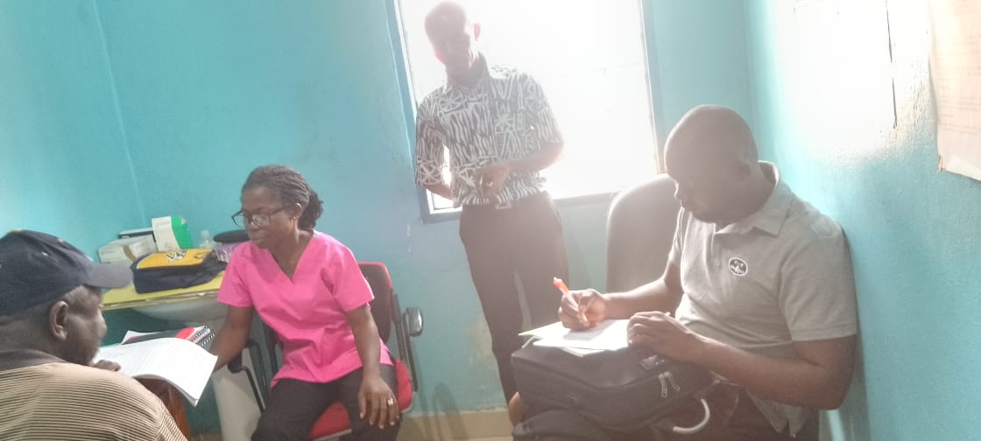Supervision and mentorship with TB clinician at Omega market Clinic

**Team Four report**

Duport Road

|  |  |  |
| --- | --- | --- |
| **Observation** | **Challenges** | **Action Taken** |
| * Facility has two clinicians, one CHP trained in TB Services * All Patients are screened using the TB screening log, Patients with a score of 3 and above are recorded in the presumptive register and sent to the lab for testing * All TB cases are tested for HIV (73 cases notified 4th quarter 2023), but out of the 9 positives only four were placed on ART * Treatment protocols are correctly adhered to and a copy of the quarter report was available | * Stock out of drug during the 4th quarter of 2023 * No space to separate coughing patients from the non-coughing ones (infectious control) | * Mentoring done on the importance of placing all TB /HIV patients on ART and proper TB/HIV collaboration between both units * Recommend that a meeting be held with the county health team on providing space for proper triage of TB patients to avoid spread of the disease |
| **Agnes Varies** |  |  |
| * 7 staff trained in TB case management and Mental Health * 3 Patients screened using the screening log * One case notified in 4th quarter 2023 * Follow-ups are not done on time * When cases are diagnosed, the clinician has to communicate with the TB/HIV focal person before the drug is taken from another facility | * Facility does not have a laboratory * The entity has not received stock of anti-TB medication | * Recommend that the facility be placed in the CMS database for routine distribution of drugs |
| **JFK Medical Hospital** |  |  |
| * 78 Cases notified for 4th quarter 2023 were all tested for HIV, out of 25 positives, only 16 were placed on ART * Facility has four trained staff in both TB and mental health * Screening Log and presumptive are in use * All treatment protocols are adhered to * All TB cases are screened for mental health with requisite tools attached to card except patients admitted on the ward | * Stock out of Recording and reporting tools (lab request form and Treatment cards) | * RR Tools provided by team * Mentoring on the usage of the Mental health screening tools |
| **Sonewein Clinic** |  |  |
| * Two staff trained in TB case management and Mental Health * 39 cases notified in the 4th quarter 2023, all have treatment cards * TB Clinician (alone) overburdened with usage of the TB screening log to screen all patients that enter the facility, patient load sometimes more than 100. * Pediatric TB drugs are nearing expiry date (March), the clinician is requesting that drugs be retrieved before they expire since there is no pediatric TB case | * High Lost to follow-up amongst disadvantaged youth/elicit substance users | * Clinicians were told that the screening log should be used at every point of entry in the clinic, to avoid the burden of screening for TB to be solely on the TB Clinician |
| **Monrovia Prison Compound** |  |  |
| * HIV tests are not being done because the facility doesn’t have an HIV service * Two HIV positive cases haven’t received ART because of the same reason above * Diagnosis and follow-up tests are not done in time because the facility lab is not functional. * 20 presumptive Cases notified, but couldn’t be tested | * No Functional Lab and HIV Unit for testing TB patients/ provision of HIV services | * TB/HIV Coordinator: TB program already started negotiation with NACP for the provision of HIV services |
| **ELWA Hospital** |  |  |
| * The team observed that only presumptive TB cases were placed in the screening Log * Delay in the results from the lab for both diagnosis and follow-up * Lab reagents are expired * The lab serial numbers are not in order * No internal quality control being done for TB | * Long turnaround time for patient results | * Mentoring for both lab technicians and TB clinician * Clinician mentored on the proper use of the TB screening Log and presumptive register |
| **St. Joseph Hospital** |  |  |
| * Lab Reagents are expired * 23 Cases notified for 4th quarter 2023 were all tested for HIV, out of 2 positives, 2 were placed on ART * Facility has two trained staff in both TB and mental health * Screening Log and presumptive are in use * All treatment protocols are adhered to * All TB cases are screened for mental health with requisite tools attached to card | * Lack of weighing scale, and gloves |  |
| **TB Annex Hospital** |  |  |
| * The team observed that only presumptive TB cases were placed in the screening Log * All treatment protocols are adhered to * All TB cases are screened for mental |  | * Clinician mentored on the proper use of the TB screening Log and presumptive register * Mentoring on the usage of the Mental health screening tools |
| * **E.S Grant Mental Hospital** |  |  |
| * All mental health patients are screened for TB * Facility has 6 trained staff in both TB and mental health * Screening Log and presumptive are in use * All treatment protocols are adhered to |  | * Clinician mentored on the proper use of the TB screening Log and presumptive register * Mentoring on the usage of the Mental health screening tools |
| **Gray Stone** |  |  |
| * Screening Log book and presumptive Register not in use * HIV services are not provided * Patients are not being screened for mental health because staff are trained * 34 cases notified | * Clinicians are not trained in mental Health Management | * Clinician mentored on the proper use of the TB screening Log and presumptive register * Mentoring on the usage of the Mental health screening tools |
| **Liberia National Police Clinic** |  |  |
| * Clinicians were just supplied with screening before the team visit * Only three patients screened as of the time of visit | * Clinician complained that the space is not conducive for treating TB Patients | * Clinician mentored on the proper use of the TB screening Log and presumptive register * Mentoring on the usage of the Mental health screening tools |

**Cut across intervention**

* All the 11 facilities visited received 15USD communication support
* Onsite Mentoring and coaching conducted at all the 11 facilities on the usages of both screening and presumptive ledgers.
* As it stands, all the facilities have screening and presumptive ledgers